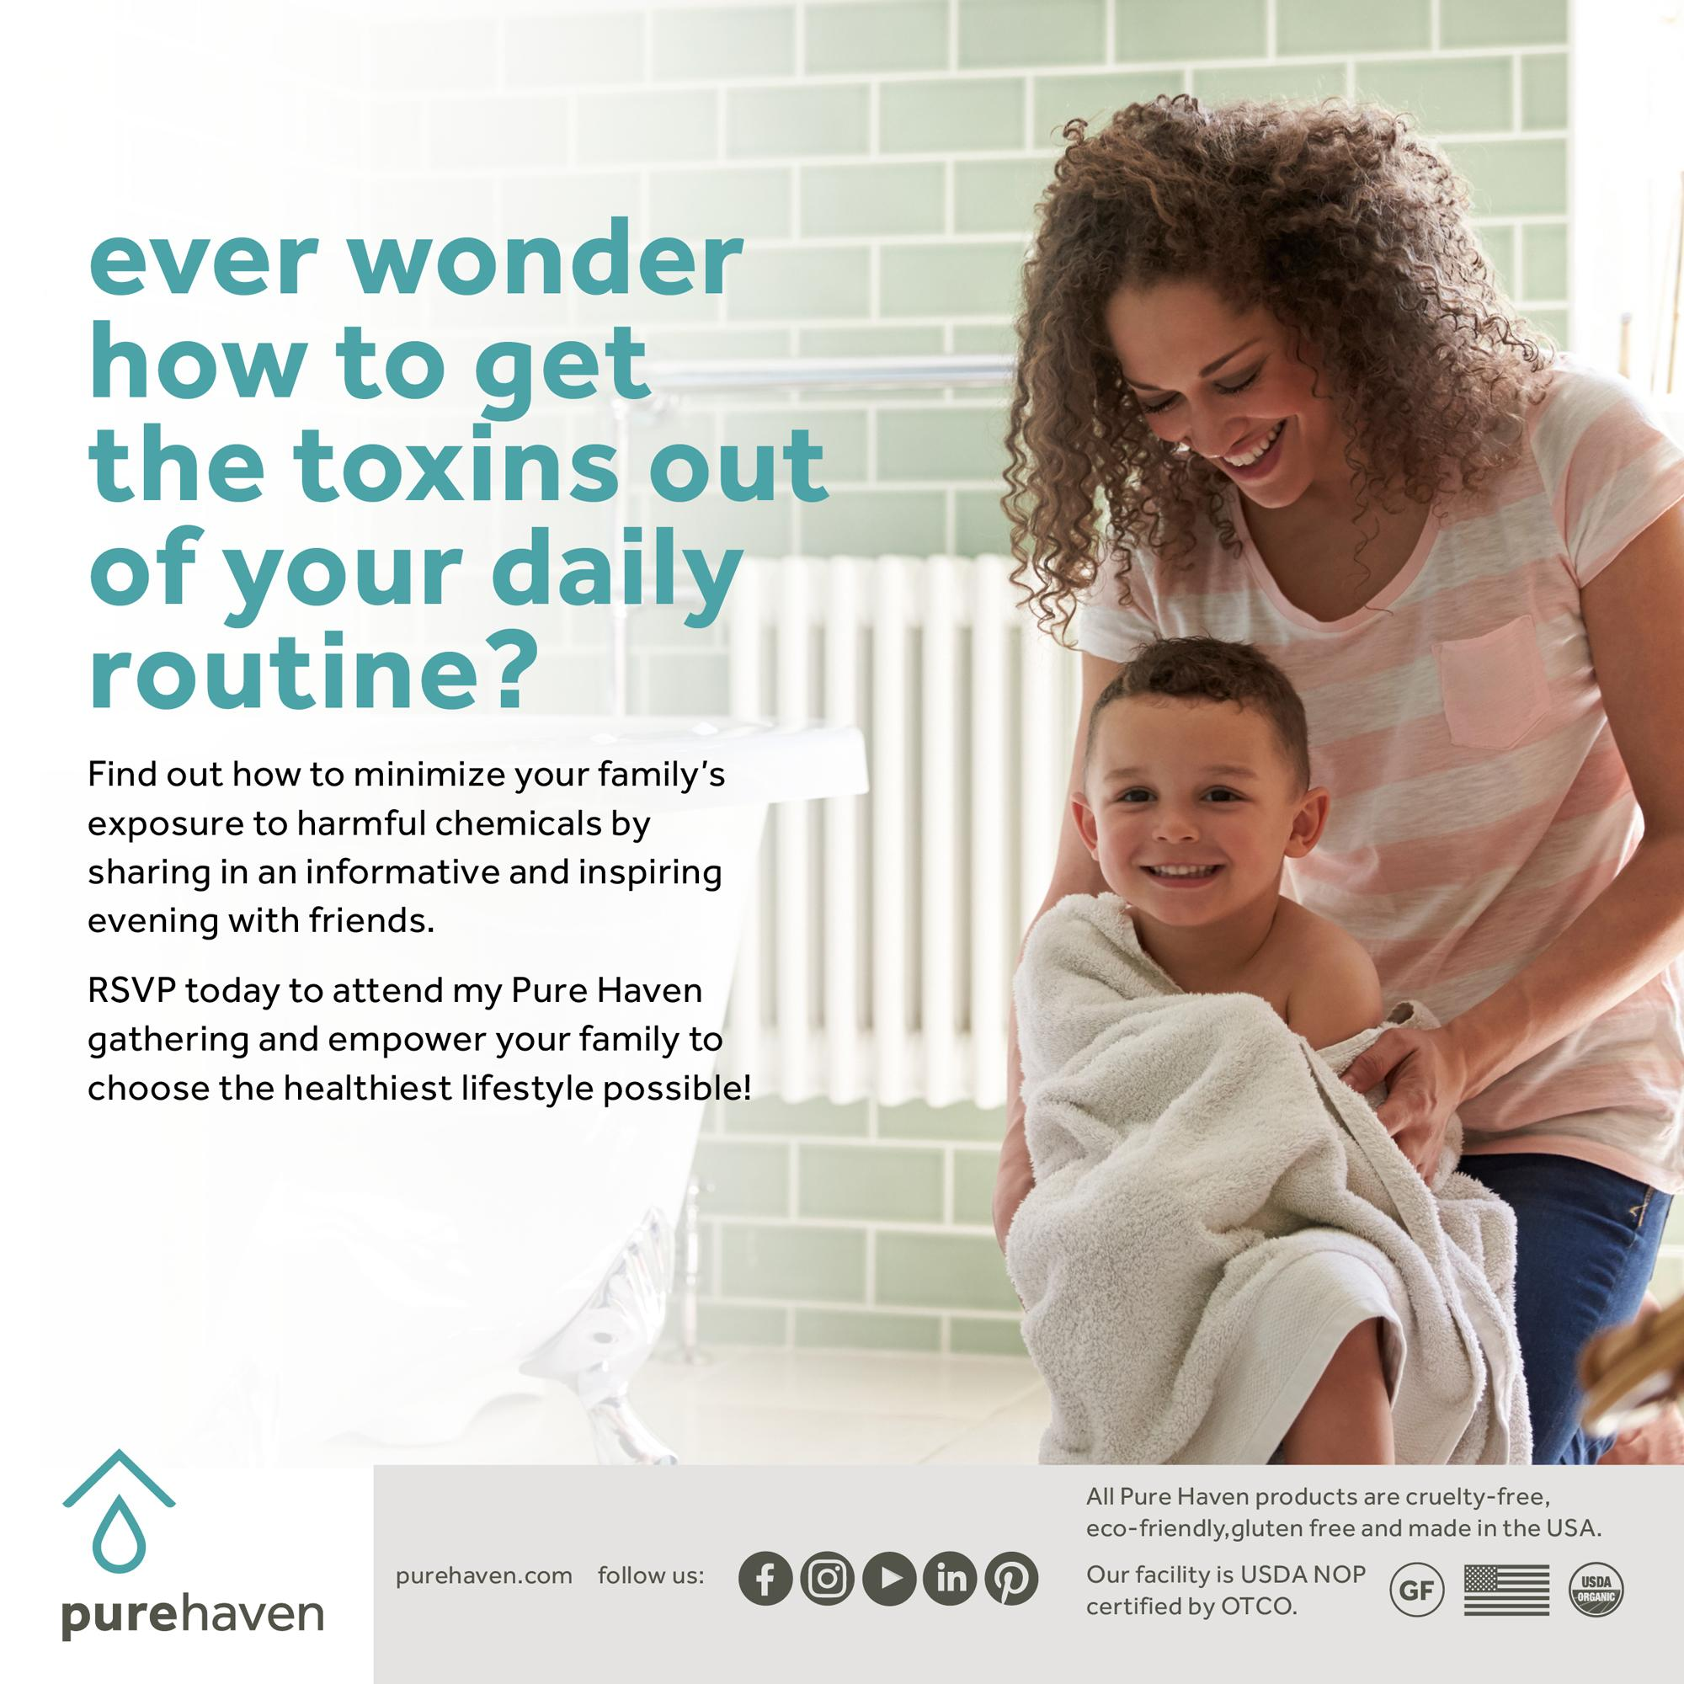

Tell us about yourself

Hi! My name is Sheila Leaden. My family and I have lived here in Wilmington for 20 years. I’ve been immersed in health advocacy for over a decade. When I am not on my yoga mat, I have a career as an Ultrasound Technologist in Boston and local community hospitals. My newest venture is that of Senior Consultant for Purehaven Essentials. This business allows me to share my passion for health advocacy and bring awareness regarding the benefits of toxic free living. While imaging the inside of people's bodies with soundwaves, I see first hand the effects of toxic chemicals from our conventional everyday products that can affect homeostasis. Sharing the wisdom that I gain by implementing the practice of toxic free living, I realize one of my life’s purposes. Alone, we can do so little, together we can do so much!

How did you find Yoga and the Yoga Loft?

I found yoga at the Yoga Loft in winter of 2007. I credit Jen Ryan and her amazing staff for instilling a wise foundation to my yoga practice. I’ve had the honor of becoming a certified yoga instructor through the Yoga Loft’s 200 hour teacher training school in 2014. I currently lead a Beginner Basic yoga class every Saturday morning at the studio and a weekly Restorative yoga class on Tuesday evenings. It fills my heart to be part of such an authentic, connected and welcoming community that the Yoga Loft upholds.

What's your favorite yoga pose?

It’s difficult to choose a favorite but I will say Sirsasana or headstand. There are many benefits from this pose such as increased focus, stress relief and core strengthening. It is not a pose that I teach in Beginner Basics or Restorative classes but I fit it into my personal practice as much as possible.

Tell us more about your business

Pure Haven is about being part of a community for positive change — a group of amazing women and men who are in the business of doing good. This business is not just about selling, but about learning, sharing, growing and achieving anything you put your mind to. Let me know if you’d like to join me on this venture. Together we can do so much!

What are the benefits of Purehaven Products?

100% Free of Toxins. No Compromises.

All of the energy and passion goes into formulating and creating fresh products that are made in small batches, free of toxins, environmentally sustainable and cruelty-free. Adhering to a strict, six-step ingredient sourcing procedure and manufacturing the products in a USDA Certified Organic local facility in small batches keeps the product fresh. Always with keen attention to health and environmental impact, Certified Organic ingredients are used whenever possible. There is value in uncompromising transparency, and we empower you to choose the healthiest lifestyle possible. Please visit www.purehaven.come/sheila for more information !
Namaste ~Sheila

